Measles Campaign Information and Q&A for Community, Voluntary & Faith Sector

Measles general information

Measles spreads very easily among those who are unvaccinated.

Measles can be a very unpleasant illness. In some children it can be very serious and lead to hospitalisation – and in rare cases tragically can cause death. People in certain risk groups including babies and young children, pregnant women, and people with weakened immunity, are at increased risk of complications from measles.

Symptoms include a runny nose, cough, high fever, sore red watery eyes and a blotchy red-brown rash.

Having two doses of the Measles, Mumps, Rubella (MMR) vaccine at the right time (dose 1 from 12 months and dose 2 from 3 years 4 months) is the best way to protect your child and help prevent it spreading, especially to those most vulnerable. Two doses of the MMR vaccine give you excellent lifelong protection. If you or your child have missed out, contact your GP surgery to catch up as soon as possible.

There has been a recent, increase in measles cases in England, including (at the time of writing) an ongoing outbreak centred in Birmingham and around the West Midlands region of England. Most of the cases have been in children under the age of 10 years with many outbreaks linked to nurseries and schools.

Uptake of the routine childhood vaccinations, including the MMR vaccine is the lowest it has been in a decade and is well below the 95% uptake needed to protect the population and prevent outbreaks. This is giving this serious disease a chance to get a foothold in our communities. Achieving high vaccination coverage across the population is important as it also indirectly helps protect very young infants (under one) and other vulnerable groups.
UKHSA has declared a national incident to coordinate the investigation and response to the rise in measles cases and this is informing communication strategies across partner organisations, ensuring facts are communicated clearly alongside a call to action.
This communications toolkit is to support UKHSA and its partners with managing communications related to the rise in measles cases and signposts to the latest materials.

Key messages on MMR vaccine
- Measles spreads very easily among those who are unvaccinated, especially in nurseries and schools. It can be a very unpleasant illness and in some children can be serious and lead to hospitalisation and complications – and in rare cases tragically can cause death. Vaccines are our best line of defence against diseases like measles and help stop outbreaks occurring in the community.
- We are calling on all parents and guardians to make sure their children are up to date with their 2 MMR doses. To see if your child is up to date with their MMR vaccines, check your child’s personal child health record (PCHR), known as the red book, or contact your GP practice. People may also be able to check their vaccination status on the NHS App.
- It is never too late to catch up. The MMR vaccine is free on the NHS, whatever your age. If anyone has missed one or both doses of the MMR vaccine, contact your GP practice to book an appointment.

- NHS advice
There is information on measles on the NHS website. This includes advice to parents and carers to check if their child has measles, including photos of the measles rash. The rash looks brown or red on white skin. It may be harder to see on brown and black skin.

Measles is a highly infectious viral illness, so anyone with symptoms is advised to stay at home and phone their GP or NHS 111 for advice, rather than visiting the surgery or A&E, to prevent the illness spreading further.

There is information available from the NHS on the MMR vaccine.

NHS national MMR catch-up campaign for children aged 6 to 11 years

On 22 January 2024, the NHS launched a catch up campaign for missed MMR vaccines.
The campaign will see all parents of children aged from six to 11 years contacted encouraging them to make an appointment with their child’s GP practice for their missed MMR vaccine.
It will target areas with low uptake of the vaccine with the health service contacting just over one million people aged 11 to 25 years-old in London and the West Midlands to invite them to catch up on their missed MMR vaccinations.
For more information about the campaign, please visit the nhs.uk website.

MMR vaccine general information

Vaccines are our best line of defence against diseases like measles and help stop outbreaks occurring in the community.

Children are offered the first dose of the MMR vaccine when they turn one and the second dose when they are about 3 years 4 months old, before they start school.

In recent years, uptake of the routine childhood vaccinations, including the MMR vaccine has fallen. Uptake for the first dose of the MMR vaccine – which protects against measles, mumps and rubella – in children aged 2 years in England is 89% and uptake of 2 MMR doses in children aged 5 years is 85%. This is well below the 95% target set by the World Health Organization (WHO), which is necessary to achieve and maintain elimination.

We are calling on all parents and guardians to make sure their children are up to date with their 2 MMR doses. It’s never too late to catch up, and you can get the MMR vaccine for free on the NHS whatever your age.

The MMR vaccine ingredients – is a halal vaccine available? – YES.

Evidence suggests there is confidence in NHS vaccination programmes and parents largely trust the advice that they get from practice nurses, general practitioners, pharmacists and from the NHS. For example, UKHSA’s annual survey of attitudes to vaccines among parents shows high confidence in the childhood & adolescent NHS vaccine programmes, which shows confidence has actually improved over the period when coverage was declining. In addition, the same survey showed almost 90% of parents understand the benefits of vaccination for their children and trust the NHS England immunisation programmes.

However, we understand the issue of pork ingredients (known as ‘porcine gelatine’) in some vaccines has raised concerns among some groups.

For background, UKHSA and NHS England has a leaflet which explains how and why porcine gelatine is used in vaccines, and the alternatives available. There is also information available on the NHS website on why vaccination is important.

- In the UK we have two types of MMR vaccine – MMR VaxPro® and Priorix®.

- Priorix® does not contain any pork ingredients and is as safe and effective as MMR VaxPro®. For both vaccines, a full two doses will provide protection against measles, mumps and rubella.

- You can request Priorix® from your GP. Parents can also make this request for children. Please note some GP practices may need to order this product in specially so it will be helpful to tell them your views before the appointment.

All GP practices have the non porcine halal Priorix vaccine available.

Measles and Autism

The MMR vaccine is not linked to autism. There's no evidence of any link between the MMR vaccine and autism. There are many studies that have investigated this. The Oxford University Vaccine Knowledge Project website has a list of MMR studies and their findings

Measles – Spot the Signs

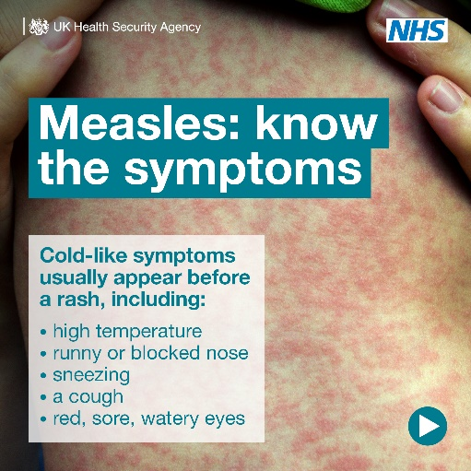 | 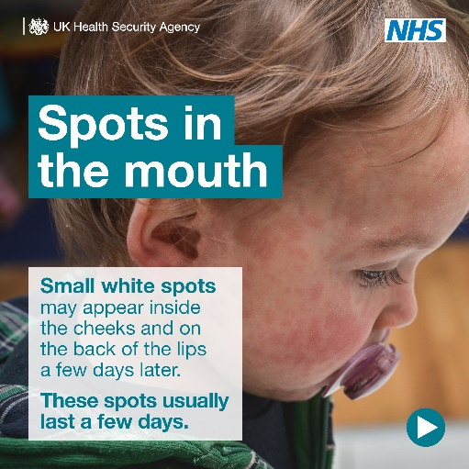
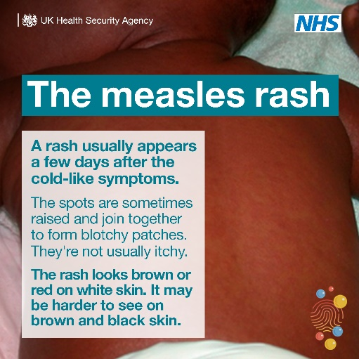 | 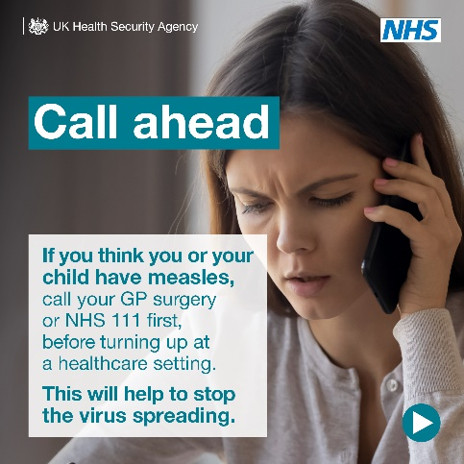

Measles – International Travel

Measles can have serious and sometimes fatal consequences and is still common in many countries worldwide. Before you travel, make sure you & your loved ones are up to date with MMR vaccinations.

